SOIL AS A FILTER (or “Cleaning Water with Dirt”)

INTRODUCTION
Water is one of our most valuable resources. We drink it, cook with it, clean with it, and are even mostly made of water! Without water, life as we know it could not exist. In order for us to stay healthy, the water we use must be relatively clean. Addition of unwanted chemicals or bacteria to our water can make it unsafe to drink or use for cleaning.

Rain water that falls on the Earth’s surface soaks into the soil (infiltrates) and can end up as groundwater or as surface water. Soil is a natural filter that captures unwanted chemicals and bacteria out of water as is travels through the ground into rivers and aquifers.

Water that moves through shallow soil often travels through wetlands before it flows into rivers and lakes. Wetlands act as “kidneys” on the landscape by filtering contaminants out of the water before it reaches the river. The soils in wetlands are important filters that keep pollution and excess nutrients out of streams and rivers. Groundwater is water that is stored deep underground in the spaces between soils and rocks. The areas belowground where water collects are called aquifers. Most of our drinking water comes from groundwater aquifers. Artificial soils (like we will make here today) are used to purify wastewater from cities, farms, and industry.

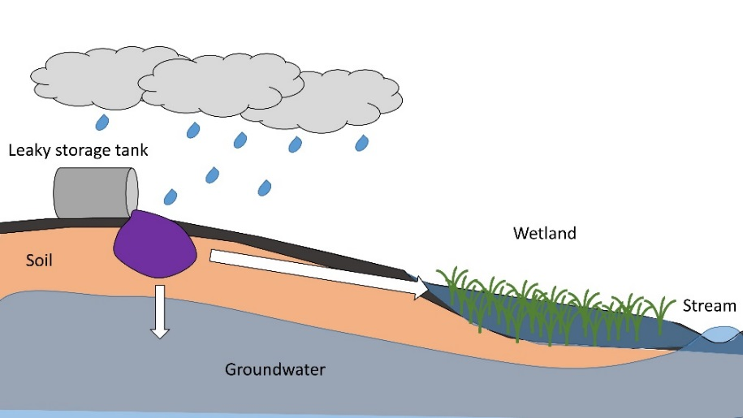
PROJECT GOAL
A storage tank is leaking harmful chemicals into the ground, and those chemicals are being washed into a nearby stream every time it rains. Today, we will construct a soil that will filter pollution out of the “dirty” water before it reaches the stream or groundwater.

VOCABULARY
Soil – the thin surface layer of the Earth where plants growth that is made of a mixture of minerals, organic matter, air, and water
Pollution – an unwanted substance that can have harmful effects on people or the environment
Filter – a porous (holey) material that allows air and water to pass through while removing unwanted substances
Gravel – rock that has been broken up into smaller pieces
Mineral soil – soil that contains mostly minerals and rocks with little to no organic matter; mineral soil is formed from the physical and chemical breakdown of rock by air and water
Organic soil – soil that contains mostly decaying plant and animal tissue with few minerals
Permeability – a measure of how quickly water passes through soil
Porosity – the amount of open space (pores) present in a soil that is filled by air or water
SUPPLIES

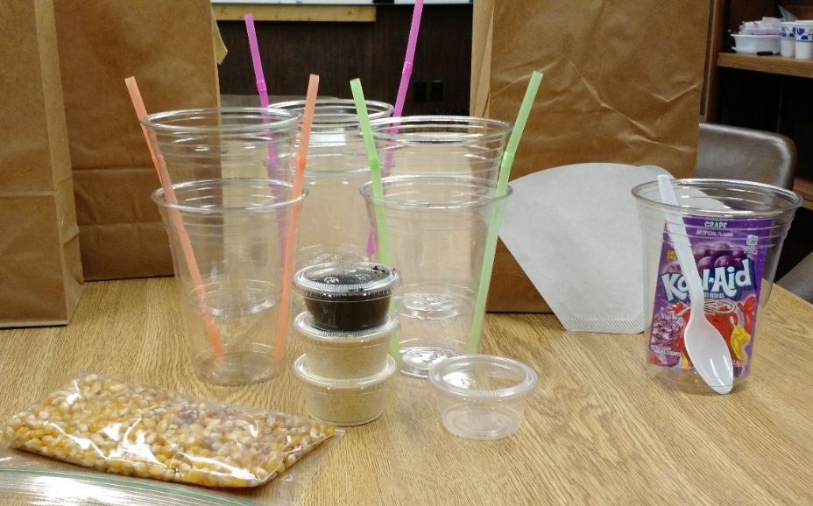
- 1 cup for mixing the “pollution”
Each demonstration kit should include the materials and setup shown in this picture.
- 6 clear cups (18 oz), 3 of which have 3-4 holes poked in the bottom
- 1 spoon
- 2 straws (or toothpicks or bamboo skewers)
- 1 packet of sugar-free purple Koolaid (or 2 drops each red and blue food coloring)
- Water
- 1 baggie of popcorn kernels (= 3 mini-cups)
- 2 mini-cups of cornmeal
- 1 mini-cup of topsoil
- 1 empty mini-cup (2 oz)
- 1 coffee filter
- optional: raisins or another small item to represent suspended particles – solid material that gets carried along by flowing water

BEFORE YOU BEGIN: OBSERVATIONS
- Describe the differences between the materials (popcorn kernels, cornmeal, topsoil).

- Which material has the largest space in between grains? Which has the smallest?

- Which material do you think will allow water to flow through the fastest? Slowest?

DIRECTIONS

- Fill one cup with tap water. This is our “clean” rainwater. Now add one packet of purple Koolaid to the water and mix it with the spoon. This is our “polluted” water that has been contaminated with unwanted chemicals leaking out of the storage tank.
Q. How are the clean and polluted water different? Do they look, smell, or taste different? Notice that the pollution was solid but became dissolved, or part of the liquid, when we added it to the water.

- Splash a couple drops of the polluted water on the coffee filter.
Q. What happens to the color of the Koolaid as it soaks into the filter? What does this tell you about the purple Koolaid?

- Take one plastic cup with holes poked in the bottom and place it inside another cup that does not have holes in it. Put two straws in between the cups to create a space so that the cups do not create a seal. This will be used to hold our soil column.

- Using the mini-cup as a scoop, add one scoop of popcorn kernels to the top cup. The popcorn will be our “gravel”.

- Now, pour one scoop of the polluted water into the cup with the gravel. Observe the water flow through the soil column. Repeat as necessary.
Q. How quickly does the water flow through the gravel? Does the water look any different than what was poured in?

- Use two more plastic cups to make a second soil column. Add one scoop of popcorn kernels. Then, pour one scoop of cornmeal on top of the kernels. The cornmeal represents the mineral soil that we see near the Earth’s surface overlying rock and gravel.
Q. Does the mineral soil look different than the gravel? How are the sizes of the individual grains of gravel and mineral soil different? What do you predict will happen when you pour the polluted water through the gravel + mineral soil filter?

- Pour one scoop of the polluted water into the cup with the gravel + mineral soil. Observe the water flow through the soil column. Add another scoop of water if needed.
Q. How quickly did the water flow through the gravel + mineral soil filter? How did the polluted water change as it moved through the filter?

- Use two more cups to set up the third soil reservoir. In the top cup, add one scoop of popcorn kernels, then one scoop of cornmeal, then one scoop of topsoil. The topsoil represents the organic soil that is made up of decomposing plants and is typically found right at the Earth’s surface. Wetlands have very thick layers of organic soil.

- Pour one scoop of the polluted water into the cup with the gravel + mineral soil + organic soil. Observe the water flow through the soil column. Add another scoop of polluted water if needed.
Q. How quickly did the water flow through the gravel + mineral soil + organic soil filter? How did the polluted water change as it moved through the filter?

- Clean and dry the cups, straws, and popcorn kernels. Discard the cornmeal and topsoil.

THINK FURTHER
- Which material allowed water to flow the fastest (highest permeability)? Why might this be true?

- Which material caused the water to flow the slowest (lowest permeability)? Why might this be true?

- Based on your experiments, how and why does grain size influence how quickly water can flow through the soil?

- Which soil made the best filter? How did you decide this?

- What properties of the soil helped it act as a filter?

- Is the water that gets filtered through the soil totally clean? What do you think this means for polluted water in the environment?

Optional additional activities:
- Have students collect a cup of soil from their backyard and use it as a filter. Examine the properties of each soil. Do different soils have different abilities to filter out the pollution? If so, why might this be?
- Observe an exposed soil profile along a road cut or valley. Can you identify different layers of rock, mineral soil, and organic soil?
RESOURCES

Activity adapted from How Dirt Cleans Water (http://www.scientificamerican.com/article/how-dirt-cleans-water/) and Soil is a Filter (http://www.doctordirt.org/teachingresources/soilfilter).
Dig It! The Secret of Soil: http://forces.si.edu/soils/
Groundwater: http://www.waterencyclopedia.com/Oc-Po/Pollution-of-Groundwater.html
Wetlands: https://www.epa.gov/wetlands
Food and Agriculture Organization of the United Nations: http://www.fao.org/soils-portal/

Think further: Notes
- Which material allowed water to flow the fastest (highest permeability)? Why might this be true?
The gravel (popcorn kernels) allowed water to flow the fastest because the pores – spaces between the grains – were large and well-connected.

- Which material caused the water to flow the slowest (lowest permeability)? Why might this be true?
The mineral soil (cornmeal) caused the water to flow more slowly because the pores – spaces between the grains – were much smaller, creating a maze for the water that slowed it down.

- Based on your experiments, how and why does grain size influence how quickly water can flow through the soil?
Smaller particles pack together more tightly, which makes the pore spaces smaller and slows down the water.

- Which soil made the best filter? How did you decide this?
The best filter had both mineral soil and organic soil added to it. The combination of these soils helped filter out both the red and blue dyes.

- What properties of the soil helped it act as a filter?
Smaller grains slowed down the water and trapped the pollution through both physical and chemical means. Physical – particles get trapped in the soil because they are too big to move through the small spaces between the grains. Chemical – the dyes are positively and negatively charged and “stick” to soil grains with the opposite charge.

- Is the water that gets filtered through the soil totally clean? What do you think this means for polluted water in the environment?
The soil filters out most of the pollution, but the filtered water is not as clean as the original water. Once water is polluted, it is very difficult to clean. This is especially true for groundwater that is stored deep belowground.

